**KIET Group of Institutions, Ghaziabad**

**Computer Science**

**Internship Report**

**on**

**IBM Skill Build Internship Program**

**Summer Internship at AMERICAN INDIA FOUNDATION**

**July**

**(2021)**

**Submitted By:**

**Ujjwal Kumar**

**Computer Science(Sem- IV)**

**Class Roll No.- 53**

**INDEX**

**Content Page No.**

1. Acknowledgement 3

2. Report Certificate 4

3. Industry Profile 4

4. Overview of Project 5

5. Introduction to Project Internship 5-6

6. Details of Project 7

7. Learning Outcomes 7

9. MOOC Certificate 8

10. Literature Review Report 13-23

11. Daily Log Report 24-26

**ACKNOWLEDGEMENT**

I’ve got this golden opportunity to express my kind gratitude and sincere thanks to my Head of Institution, KIET Group of Institutions of Engineering and Technology, and Head of Department of “**Computer Science”** for their kind support and necessary counselling in the preparation of this project report. I’m also indebted to each and every person responsible for the making up of this project directly or indirectly.

I must also acknowledge or deep debt of gratitude each one of my colleague who led this project come out in the way it is. It’s my hard work and untiring sincere efforts and cooperation to bring out the project work. Last but not the least, I would like to thank my parents for their sound counselling and cheerful support. They have always inspired us and kept our spirit up.

**Ujjwal Kumar**

**B.Tech**

**Semester- IV**

**University Roll No: 1900290120124**

**CERTIFICATE**

This is to certify that the internship project report entitled **"IBM Skill Build Internship Program"** submitted by **Mr. Ujjwal Kumar** in the Department of **Computer Science** of KIET Group of Institutions, Ghaziabad, affiliated to Dr. A. P. J. Abdul Kalam Technical University, Lucknow, Uttar Pradesh, India, is a record of candidate summer internship. He has successfully completed his/her internship under my supervision and guidance and is worthy of consideration for the same.

**Supervisor’s Name: Prof. Manish Bhardwaj**

**Date: 23/09/2021**

**INDUSTRY PROFILE**

The **American India Foundation** (AIF, founded 2001) is a non-profit American organization working in India. It is one of the largest secular, non-partisan American organizations supporting development work in India.

American India Foundation collaborated with IBM to provide free communication skills training on IBM skill build learning platform.

On this platform students can learn various skills related to communication as well as technical skills.

**Overview of Project**

Project was based on communication skills like How to make resume, how to behave in interviews , how to make LinkedIn profile and many more soft skills.

It started in first week of July and lasted for 2 weeks.

In this internship we were assigned to complete some skill based courses on IBM Skill build platform like Personality Dynamics , How to Dress up for Interview, How to Make LinkedIn Profile , and many more.

We were also introduced with basics of web development like how web works and structure of website and basic components of websites and languages used to make the website i.e. Html, CSS, Javascript.

One session was also conducted for basics for machine learning where different frameworks and modules related to machine learning were introduced to us.

**Introduction of Project Internship**

American India Foundation collaborated with IBM to provide free communication skills training on IBM skill build learning platform.

Project was based on communication skills like How to make resume, how to behave in interviews, how to make LinkedIn profile and many more soft skills.

In first week we are taught about the need of the communication skills, why it is important in our professional career and in future education.

We were also taught about LinkedIn how to prepare profile on LinkedIn and how to prepare for interview.

We were taught about different aspects of personality development as well as technical skills and how its going to be beneficial for us in future.

We were also taught about video resume how it will give an edge to us compared to the other candidates.

We were also introduced with basics of web development and machine learning

**Outcome of Internship**

Through this internship I have learnt a lot about personality development, communication skill, soft skills and basics of web development.

Through this internship I learnt about LinkedIn, how to make our profile better for better showcase of my technical as well as soft skills and to connect with the peoples with same interest.

I also learnt about Job essential skills like how to dress up for interview, how to talk to the interviewer and responds to interview question and how to tackle different scenarios and problems.

I have learned about time management skills how we can manage our time for better productivity during work and study.

**Internship Certificate**

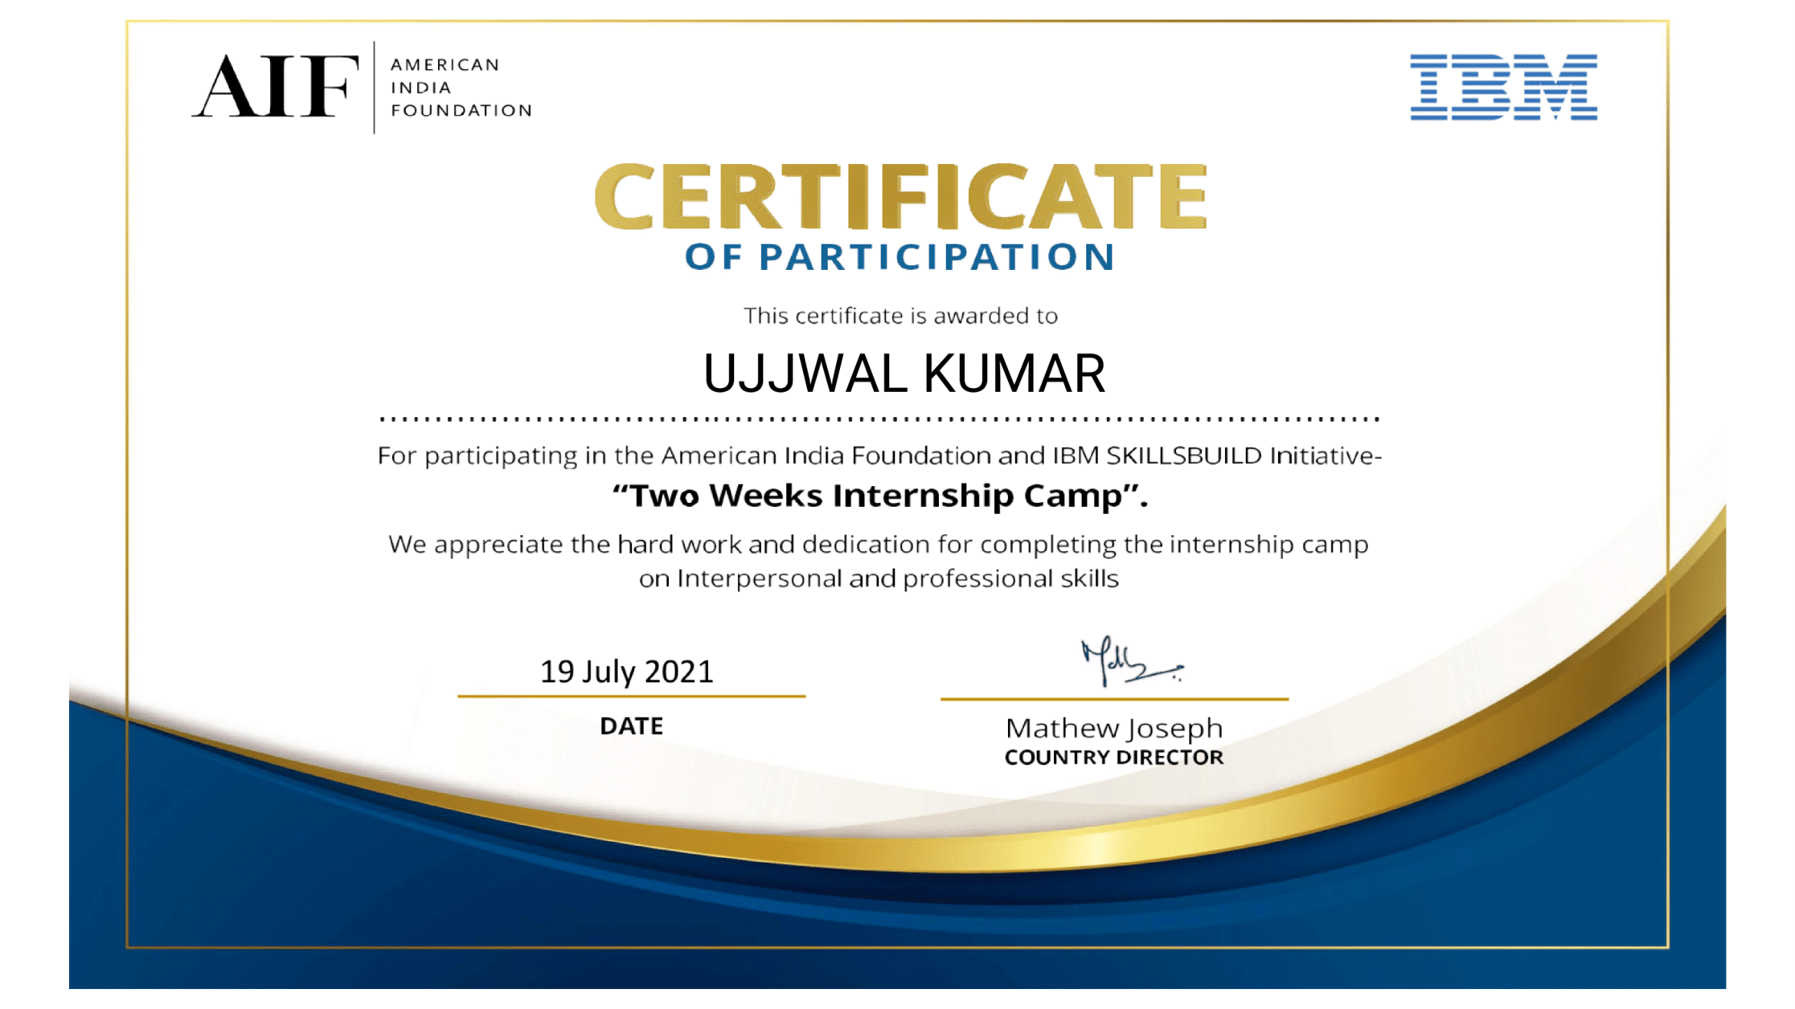

**MOOC Certificate**

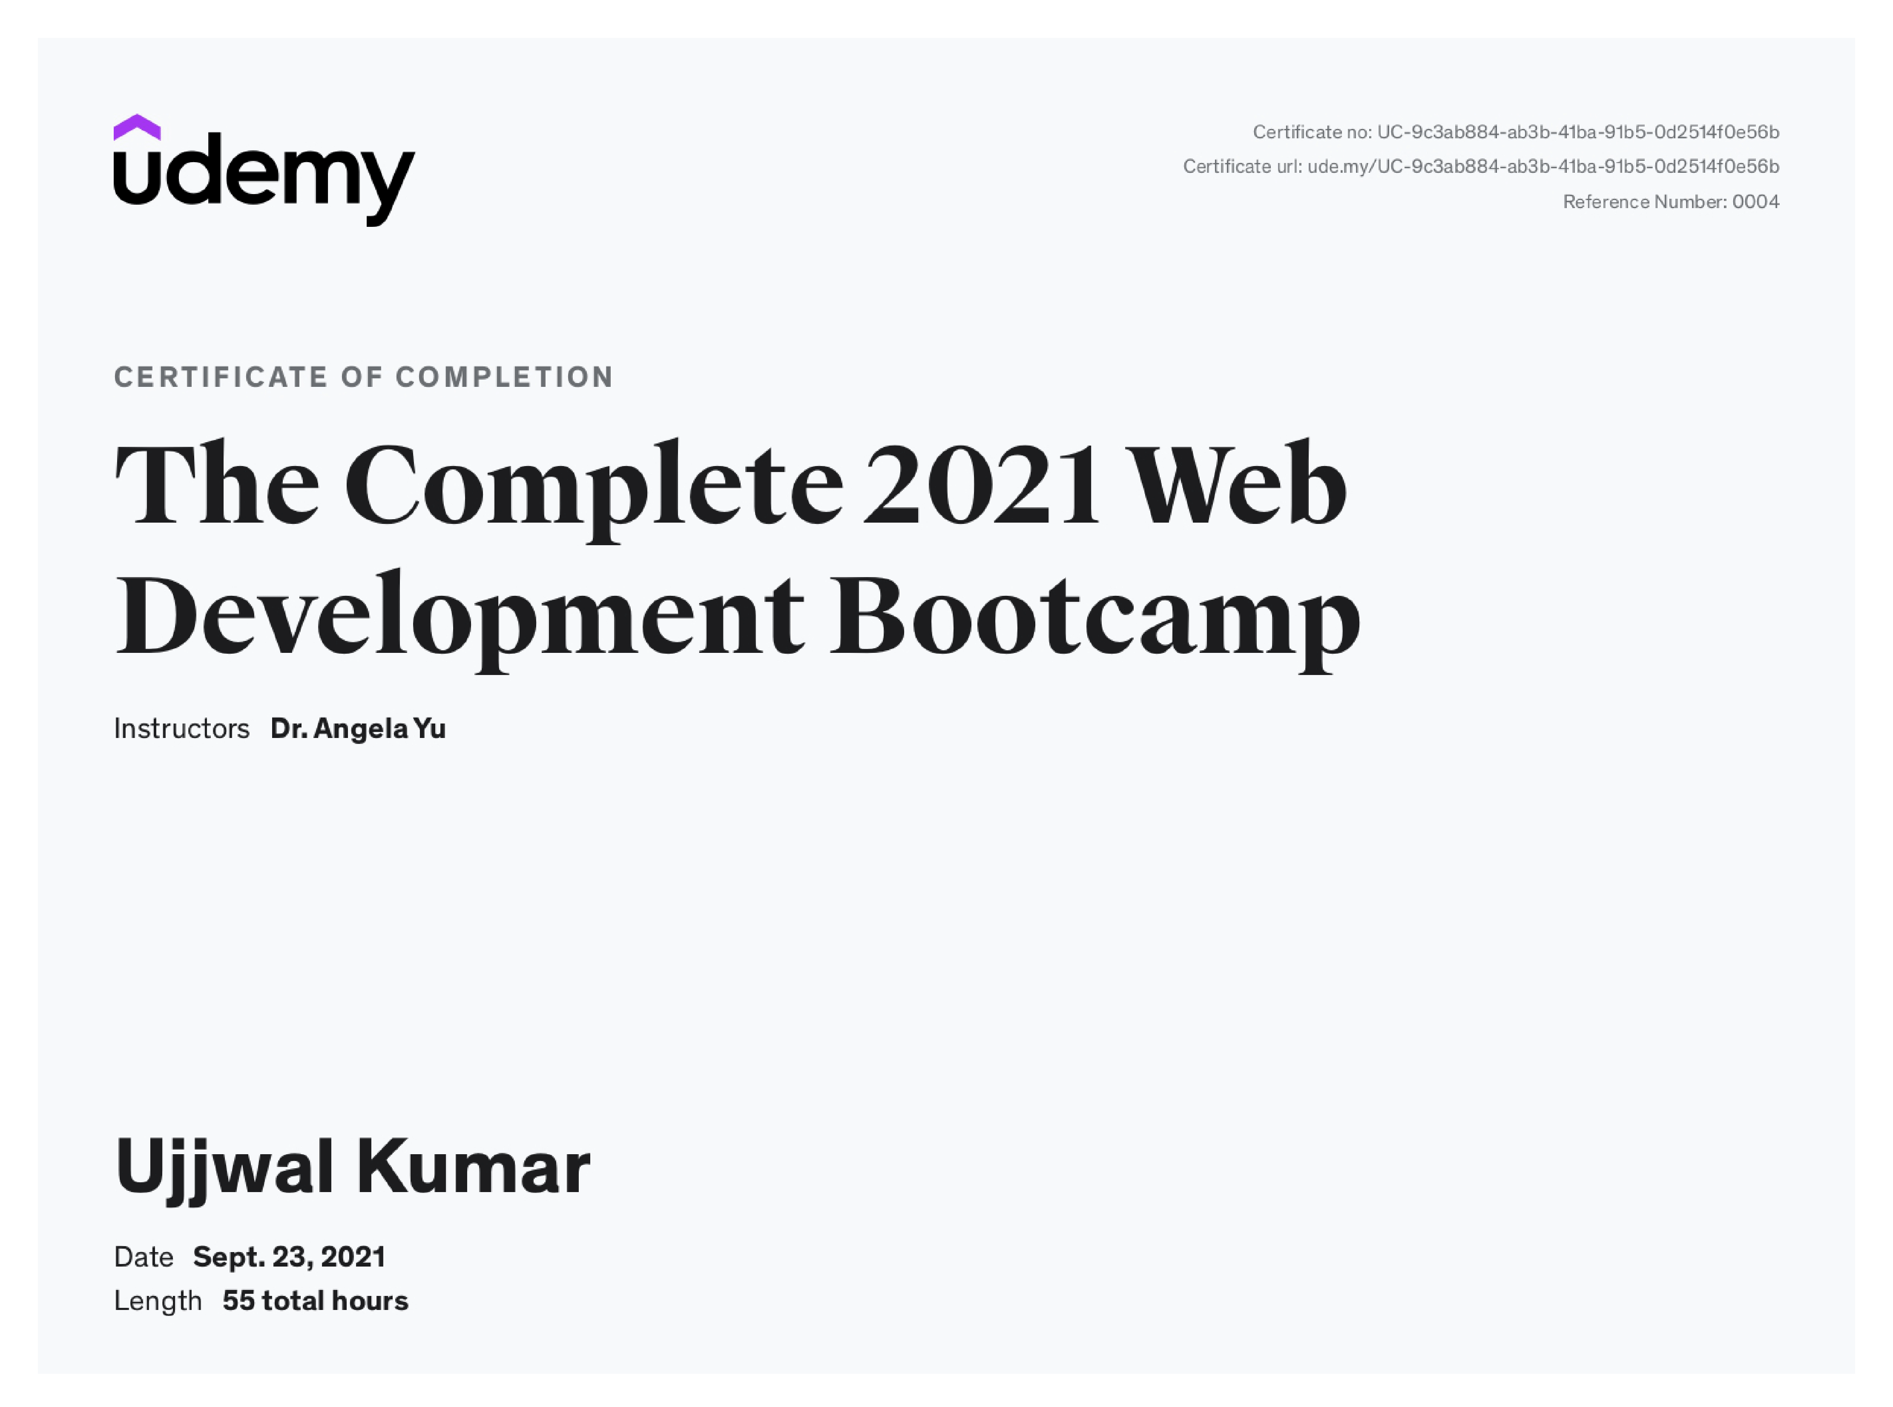

Verification link: https://www.udemy.com/certificate/UC-9c3ab884-ab3b-41ba-91b5-0d2514f0e56b/

**Literature Review Report**

**RESEARCH PAPER-1**

**Research on HTML5 in Web Development.**

**Link:**

**http://ijcsit.com/docs/Volume%205/vol5issue02/ijcsit201405**

**02328.pdf**

**Abstract:**

Web is a resource that is widely and steadily usable across many

platforms. Some vendors have developed their proprietary technologies

that provide more functionality than web standards such as the ability to

build rich internet applications.

It can play audio and video and supports animations from the browser

without the need of the proprietary technologies.

Some vendors have developed their proprietary technologies that

provide more functionality than web standards such as the ability to

build rich internet applications. Provide the proprietary formats for

running a web application. The basic advantage for the developers and

browsers is that they would be able to do more without the need of

mastering or licensing multiple proprietary technologies that can

develop rich web pages, enhanced forms and web based applications.

HTML5: HTML5 is a new standard for HTML which allows us to build rich and interactive web pages which bring HTML into the world of

application development started in the year 2004.

HTML moves from describing the basics of a text based web for

presenting audio, video and animations to enabling offline functionality,

geo location and local storage in client side databases.

Canvas HTML5

Before HTML5 there is no standard for playing audio and AppCache

(Application Cache) allows applications to store video files on a webpage

which generally requires a plug-in data and programming code locally so

that the web for different formats of audio and video. Provides a

standard way to embed audio files and video files which includes non

proprietary formats in the web page. HTML5 provides Web Storage

feature that can store data within the user’s browser which is better than

cookies used in older version. It offers support for mobile browsers and

Location-based applications by enabling interaction with GPS and

JavaScript extensions. Working Offline HTML5 as a standard introduces

new methods for enabling a web site or web application to function even

without a network connection. New Input Types HTML5 introduced new

input types for simplifying the web page designing, even they have

inbuilt support for CSS and JS. To better serve today's web requirements,

HTML5 has introduced new elements for drawing graphics, displaying

media content, for better page structure and better form handling, and

several new APIs for drag and drop, for finding your geological location,

for storing local data, and more. All the HTML5 features mentioned

above provides feasibility for the users and developers in developing

web applications without the use of plug-ins. HTML5 introduces new

elements and features that allow developers to improve interoperability,

handling elements.

**Research Summary- 2**

**Web Application Development: Java, .Net and Lamp at the**

**Same Time**

**Link:**

**https://link.springer.com/content/pdf/10.1007%2F11531371_**

**26.pdf**

**Abstract:**

Web applications are usually built starting from incomplete design

documents and proceeding directly to implementation for some specific

software platform. The resulting application is usually difficult to change

or extend. Although several methodologies have been proposed in the

last few years, most of them use a concrete approach that leverages the

features of a specific software platform or concrete Web elements.

Model-driven development proposals, on the other hand, are difficult to

adopt. This paper discusses a successful intermediate approach that

allows the designer to work with abstract artifacts that can be readily

mapped into any MVC-based (application) framework, independently of

which software platform is used. This methodology is simple and easy to

learn, even by those who are not platform experts. We present it in

terms of a real-life running application for use by local governments in

Chile.

Introduction

Society has become increasingly dependent on the Internet. In the wake

of this phenomenon, software developers are finding themselves under

pressure to build increasingly complex applications in less and less time.

• As for the second approach, many designers are reluctant to adopt

a platform independent methodology

• They find that it has little connection with the world they are

dealing with and feel it will take too long to arrive at a real solution

once everything is modeled in the abstract world.

• Most of these proposals share a troubling characteristic: they do

not capture the fundamental characteristics of every Web

application

• Their level of abstraction goes beyond middleware (i.e., J2EE,

ASP.NET) to achieve Web independence, and their guides and

artifacts can be used to model a classic non-Web application.

• The application operates in round-trip fashion, accepting user

requests, processing them, and responding in HTML code

• Making use of these restrictions, the level of abstraction of the

models can be lowered to achieve an easier implementation, while

still maintaining it high enough so the models can be used in any

concrete Web platform.

• In the rest of the paper we present we present our approach trough

a running example

Example Application

Our running example is a simple real Web application that allows vehicle

owners in Chile to pay vehicle license fees to their local governments

over the Internet (CLIP, for Car License Internet Payment).

• Chile requires that every vehicle have a valid license, which must

be renewed on an annual basis.

• The vehicle owner, known as a “contributor”, pays an amount

based on the vehicle’s appraised and insured values to the local

municipality.

• The contributor must present a vehicle inspection certificate from

an inspection station stating that the vehicle complies with road

safety and environmental regulations.

• Once CLIP has collected all the necessary information for the

license payment, it should notify the Payment-Module regarding

the transaction to be performed in order to complete the process.

Mapping to Specific Implementation Platforms

It is quite easy to get from here to the actual Java platform or ASP.NET

design.

• We have developed detailed mappings for Java and ASP.NET.

• These two mappings are based on typical architectures for Java and

.Net In a generic MVC Java architecture, a servlet receives the

browser requests, filters them using the application filter classes,

delegates their processing to the application controller classes, and

chooses a JSP to send the display of the interaction context.

• In the generic ASP.NET architecture, when a request for an ASPX is

received, the asp elements are fed by the corresponding Code

Behind.

• When a request from an ASPX form is received, its corresponding

Code Behind processes it by querying and updating the application

Model.

• If the page is inherited from a filtered Web page, filtering is

performed before any page processing

Conclusion

We have presented a methodology for creating Web applications that

allows postponing platform specific details up to the very end of the

project.

• Since the abstract artifacts relate closely to the concrete ones that

appear in any MVC-based framework, the final mapping is direct

and easy to perform.

• Our approach can be learned by Web developers and put to use

almost immediately.

• Future tasks include process formalization and tool development

for semiautomatic mapping of abstract to concrete artefact.

**Research Summary- 3**

**A Revised Web Objects method to estimate Web application**

**development effort.**

**Link:**

**file:///D:/OneDrive%20-**

**%20Student%20Ambassadors/A_revised_web_objects_method_to_esti**

**mate.pdf**

**Abstract:**

In particular, we consider: - the codification of specific steps to

compute the effort, starting from well-defined parameters; - the

involvement of human factors; - the capability to establish a

relationship between the system dimension, expressed using a

dimensional metric, and the effort measure given as output. These

techniques are strongly experience-driven, and are based on the

human knowledge of the process, of the development team and of all

the influencing factors. Finally, in the mixed model category, we group

all the other cases, in which there is not a clear boundary between the

influence of the "human factor" and of the algorithmic component.

Introduction:

Among all, the mixed approach presents the advantage to merge two

aspects equally important in the evaluation of complex software

objective measures and subjective factors linked to the experience and

the ability to follow the quick evolution of the programming

technologies, for instance characterizing the development of Web

applications.3. In our previous research, we considered the real data of

a set of Web projects in the context of Datasiel spa, a mid-sized Italian

software company. On the basis of this previous work, we devised the

new RWO method, that takes into account the classical parameters of

WO recomputing the original indicators and, when we deem they have

become obsolete due to new advances in the technology, incorporates

our practical experience in effort estimation. Of course, it is usually

necessary to tune the proposed RWO method with respect to a

productivity coefficient that depends on the adopted technology and,

consequently, on the experience of the company performing specific

projects. Following the original WO indications, the elements we

considered in RWO are divided in operands and operators, defined as

following: - operands: the elements themselves - operators: the

operations we can perform on the operands Actually, in various counting

examples (particularly in the White Paper describing the official counting

conventions [8]), Reifer himself does not use this equation, but he just

sums operands and operators, each weighted by a number depending

on the complexity of the considered item. We use the same approach for

the four kinds of operands introduced by Web Objects, in the followings

described with related operators and complexity weights for "Low,

Average, High" grades, reported inside the parenthesis after the name of

the element, in the same order. In the original definition, Multimedia

Files (complexity low or average, depending on kind of multimedia files)

are dimension predictors developed to evaluate the effort required to

integrate audio, video and images in applications. They are used to

evaluate the effort related to the multimedia side of a web page. In this

case, the image considered are those related to the content of a website

(for example the photos or thumbnails in a photo gallery, not the images

present in the interface. The text eligible to be considered as multimedia

file is not the text present in a web page, but text files, for instance

in.pdf,.doc,.odt, and other formats. All these operators have a Low

complexity.- Logos, headers and footers are all static elements present

in the website interface. This kind of elements are often unknown in the

early stage of a project.

**Research Summary- 4**

**WEB DEVELOPMENT The differences, similarities and in betweens.**

**Link:**

**https://link.springer.com/chapter/10.1007/978-1-4757-4852-9_37**

**Abstract:**

The IS literature reveals considerable effort concerning the development

of web-based systems. Particularly the differences and similarities

between traditional systems development and web development and

the applicability of traditional development methods are widely and

controversially discussed. However, the discussions are still primarily

based on normative arguments and lack support of empirical evidence

(Eriksen, 2000).

1. INTRODUCTION:

The IS literature reveals considerable effort concerning the development

of web based systems. Particularly the differences and similarities

between traditional systems development and web development and

the applicability of traditional development methods are widely and

controversially discussed. However, the discussions are still primarily

based on normative arguments and lack support of empirical evidence

(Eriksen, 2000). This paper reports on an empirical investigation of how

web-based systems are developed in practice and what the differences

and similarities between traditional systems development and web

development are, as perceived by practitioners working in the industry.

The purpose is 1) to understand the interplay of elements that influence

and structure the development of web-based systems in practice and 2)

to understand the diverse and often conflicting opinions about web

development in a broader context. The paper is structured as follows:

section 2 introduces the background and related work of the study.

Section 3 introduces the research framework and method, which is used

for data collection and analysis. The empirical findings are presented in

section 4 and discussed in section 5. The last section provides a summary

of the main conclusions. 2. BACKGROUND Based on an empirical

investigation of three companies working on "internet time", Baskerville

and Pries-Heje (2001) identified ten characteristics of web development.

They report that the two defining characteristics of web development,

time pressure and requirements ambiguity, have to lead to a shift away

from methodology in its traditional Karlheinz Kautz and Sabine Madsen,

Copenhagen Business School, Department of Infonautics, 60, DK-2000

Denmark. Constructing the Infrastructure for the Knowledge Economy

Edited by H. Linger et al., Kluwer Academic Plenum Publishers, 2004 495

496 KARLHEINZ KAUTZ AND SABINE MADSEN toward a more pragmatic

application of prototyping, frequent releases, parallel development,

systems architecture, early coding and an increased focus on negotiable

quality, good people and new work structures. However, these have

been identified as characteristics of systems development long before

web-based intonation systems became a topic of concern (see for

example DeMarco and Lister, 1987; Greenbaum and Stuedahl, 2000; on

the issues of time and Ross and Schoman, 1977; Pape and Thoresen,

1987; Curtis et aI., 1988; and Grudin, 1991, on the problem with complex

and ambiguous requirements) and they have been part of the general

discussion of the appropriateness and applicability of existing methods

for systems development (see for example Bansler and Bl3dker, 1993;

Fitzgerald, 1998). For instance, prototyping has been discussed as a

means to solve the problems inherent in development of all kinds of

applications since the mid 1980's (see for example Floyd, 1984; Budde et

ai., 1992). In line with this, Vidgen (2002) argues that the ten concepts

proposed by Baskerville and Pries-Heje (2001) have a more general

relevance for systems development. Instead he suggests that the

concrete differences between traditional systems development and web

development are that in web development the application is more

directly related to strategic business goals, the development focus is on

the graphical user interface and the typical user is a customer rather than

an employee. Vidgen et ai. (2002) state that the similarities between

traditional development and web development are due mainly to

increased reliance on databases and integration with enterprise

applications and they speculate that as the scope of web projects grows

larger, the similarities will outnumber the differences. We have also

previously argued that large-scale, technically complex web projects do

not differ significantly from traditional systems development projects

(Kautz and Madsen, 2002). Besides the ongoing discussion of the

appropriateness of systems development methods in general (Kautz and

Pries-Heje, 2000; Truex et ai., 2000), one stream of literature argues that

the traditional methods are applicable for web development (Chen et aI.,

1999; Murugesan and Deshpande, 2001), while another stream claim

that development of web-based systems is fundamentally different and

therefore entirely new methods and approaches are required (Braa et

aI., 2000; Baskerville and Pries-Heje, 2001; Carstensen and Vogelsang,

2001). Between these extremes it has been suggested that front-end

oriented web development (of the user interface) requires new methods

and approaches, but back-end oriented and technically complex web

development (of the functionality) should still rely on traditional

methods (Pressman, 1998). This is in line with Howcroft and Carroll

(2000), Eriksen (2000) and Vigen (2002). Howcroft and Carroll (2000)

state that many new web site development methodologies have focused

almost exclusively on the user interface, without addressing the wider

issues of web-based systems development. Further More, based on an

empirical study Eriksen (2001) concludes that traditional development

methods are useful for development of back-end functionality, but

provide little guidance with regard to the web-based front-end and Vigen

(2002) argues that web-based systems development requires a mix of

web site development techniques aimed at the front-end together with

traditional systems development methods for database modelling and

systems design.

**RESEARCH PAPER- 5**

**Device-to-Device Communications for National Security and**

**Public Safety**

**Abstract:**

Device-to-device (D2D) communications have been proposed as an

underlay to long-term evolution (LTE) networks as a means of harvesting

the proximity, reuse, and hop gains. However, D2D communications can

also serve as a technology component for providing public protection

and disaster relief (PPDR) and national security and public safety (NSPS)

services. In the United States, for example, spectrum has been reserved

in the 700-MHz band for an LTE-based public safety network. The key

requirement for the evolving broadband PPDR and NSPS services capable

systems is to provide access to cellular services when the infrastructure

is available and to efficiently support local services even if a subset or all

of the network nodes become dysfunctional due to public disaster or

emergency situations. This paper reviews some of the key requirements,

technology challenges, and solution approaches that must be in place in

order to enable LTE networks and, in particular, D2D communications, to

meet PPDR and NSPS-related requirements. In particular, we propose a

clustering-procedure-based approach to the design of a system that

integrates cellular and ad hoc operation modes depending on the

availability of infrastructure nodes. System simulations demonstrate the

viability of the proposed design. The proposed scheme is currently

considered as a technology component of the evolving 5G concept

developed by the European 5G research project METIS.

**RESEARCH PAPER-6**

**Summary**

**Detecting and Visualizing Web Design Patterns**

**Introduction:** This research investigates detection and visualization of web design patterns as a subcategory of HCI (human computer interaction) design patterns. Web design patterns deal with interaction problems of web application users. The design of a user interface can be evaluated in order to guarantee its usability and quality. Many efforts have been made in the domain of Software Engineering (SE) to detect design patterns in the process of reverse engineering. In order that designers contribute to this creation, there is a requirement for techniques to recognize whether designed interfaces have conformity with HCI design patterns. The detection is done through the recognition of structural features of a design pattern via static analysis of the web page code. Interactive Design Pattern Detect System: The IDPDetect system is a desktop application that is implemented through Java language. IDPDetect provides web design pattern detection and visualization services for three web design patterns implemented via hyperlinks, which are to-the-top link pattern, paging pattern and breadcrumbs pattern. The visualization service improves users’ understanding about web design patterns through representing the web design patterns with diagrams and also comments about the methods used for their implementation. Moreover, based on selection of each web design pattern for detection, brief information is displayed by the IDPDetect system. For each detected web design pattern, the system displays two options of “Diagram” and “Feedback”, which can be selected by the web site, which provides a list of HCI design pattern user. IDPDetect Evaluation: The evaluation of the IDPDetect system was conducted with respect to the objectives of assessing its general usability, functionalities, including detection and visualization of web design and fulfillment of the identified objectives for the system. Accordingly, ten articipants, who were all designers and most of them software engineering master’s students, were considered for the evaluation process of the IDPDetect system. The achieved results indicate that identified objectives and requirements of the system are accomplished through the development of the system.

Conclusion: IDPDetect is a system that detects and visualizes the web design patterns

implemented via hyperlinks in a web page. It uses a static analysis approach for detection and UML class for visualizing. It also generates a list of feedback about the implementation of the detected patterns. Moreover, visualizing web design patterns with the usage of diagrams helps user interface designers convey their ideas more easily to the members in other domains. Consequently, it improves the communications between the members of software engineering Teams.

**RESEARCH PAPER-7**

**Summary**

**Teaching Web Development Course in Information System Department**

**Introduction**: The world wide web is not only an information provider but also a huge business since most of the organization have its one website, which has increased the demand from students that they involve in the techniques necessary to develop and manage interactive web sites. In the case of introductory web development courses, the focus is more on learning new programming skills rather than on research or real world projects. Importance of Web Development: Web development has been one of the fastest growing industries in the world. It is essential for those who want to be seen and heard all over the world particularly for businesses, because having a website would enable you to reach those customers without delays, and be available for 24 hours and seven days a week. The possibilities of the profits that you could gain just by building a website that is well designed, attractive, easy to navigate, highly usable, good content, full of relevant information, enough functionalities and are capable of retaining visitors for long and make them come back again are limitless. Teaching Web Development to IS Students: Information Systems (IS) is an ademic/professional

discipline bridging the business field and the well-defined computer science field. And since all of the organization in these days working in the web, (IS) students must be able to work in and design websites.

Aim of the Course: From the client-side scripting development uses HTML/XHTML, CSS, DOM, dynamic HTML (DHTML), form layout, page templates and JavaScript. From the server-side scripting and the development of full Web-based applications uses PHP and MySQL databases. This class is concentrating on directly useful scripts and practical Web tools and technologies, as more on hands-on and project based

course.

Comparison Courses: In King Saud University (Saudi Arabia) IS department they have a web development course called Web Application Development topics include component development and reuse, distributed object technologies, multi-tier applications, client-side versus...Etc. These topics in general don’t concentrate

in building a web application using the design tools.

In YARMOUK University (Jordan), IS department have two web development courses: - Developing Web Application; Internet Services. These first courses and the modern internet technologies part of the second course will meet our needs in modifying web development course.

Course Textbooks and Advantage: Most of the student graduation projects are web sites, so studying the Presented topics is very significant and helpful in student projects. The text book used for web development course is Internet & World Wide Web: How to Program: a book that teaches the fundamentals needed to program on the Internet, provides in-depth coverage of introductory programming principles,

various markup languages. Hundreds of live-code examples of real applications throughout the book available for download and allow readers to run the applications and see and hear the outputs.

Conclusion: This course is an introductory web development courses, focuses on learning new programming skills. We have to follow this development and change the course content to cope with the advanced world. Dividing the course into two courses will do that since the second course content are the new technologies in the web. We can minimize the duration for teaching HTML and JavaScript and append the extra time for teaching the new technologies as web 2.0.

**RESEARCH PAPER-8**

**Summary**

**Improving HTML compression**

Nowadays the Hyper Text Markup Language (HTML) is a standard for Internet web

pages. It has many advantages, but its main disadvantage is being wordy, which

can be coped with by applying data compression. The primary objective of this

research was to design an efficient way of compressing HTML documents, which

will reduce storage requirements of HTML data. The main components are: a static

dictionary or a semi-static dictionary of frequent alphanumerical phrases (can be

XML tags, XML entities, URL addresses, e-mails, and runs of spaces), and binary

encoding of popular patterns, like numbers, dates or IP addresses. Two versions of

LHT have been developed: static and semi-static, both with some disadvantages.

Static LHT uses a fixed English dictionary required for compression and

decompression, whereas Semi-static LHT does not support streams as input

(offline compression) as it requires two passes over an input file, it creates a

dictionary in a first pass and stores it within the compressed file.

Two algorithms are there: Deflate (well-known from zip, gzip, and plenty of other

applications) and PPMVC (which gives very good compression effectiveness in

mediocre compression time and memory requirements), employing the same

algorithms as the final stage of LHT to demonstrate the improvement from

applying the HTML transform.

LHT has many nice practical properties:

• The transform is completely reversible (white characters are also preserved).

• The decoded document is an accurate copy of the input document.

• Moreover, LHT is implemented as a stand-alone program, requiring no

external compression utility, HTML parser, thus avoiding any compatibility

issues.

**RESEARCH PAPER-9**

**Summary**

**Lurching Toward Babel: HTML, CSS, and XML**

Introduction: HTML’s underlying idea was very simple: define a simple language that described the structure of a document and expect companies to develop software that can present such documents in different environments and according to various user options. However, this idea deviated from well established publishing practices. It was very difficult to switch from this approach to a simpler one, in which the author provides the content and specifies the logical structure, leaving the presentation to user agents.

Separating structure and presentation: The CSS approach makes documents simpler to write and maintain. You could write a single style sheet and use it for hundreds of documents. A browser can apply several style sheets to a document as a cascade, building document presentation. Ones who try to use style sheets encounter serious problems in current implementations while some have been able to make their style sheets work on both browser families. But it takes serious effort and a lot of help to circumvent browser bugs.

While some consider adding CSS to do things that can’t be done in HTML, but many see CSS just as a new way of achieving the same results.

CSS and stylesheets without cascades: The most obvious problem with CSS is the cascade itself, even if a browser implements the cascade correctly, it is still practically impossible to guarantee good presentation.

With CSS support turned on the site is indeed legible, you can present hypertext links in boxes, with colored underlines, or with unique text colors, among other stylistic characteristics. Thus, in order to avoid massive confusion a style sheet must specify colors for everything that can have color. Graceful degradation is something you can achieve using style sheets. With one style sheet, a document could be presented using either a user’s or an author’s style sheet, or just the browser’s default settings. Hence, the CSS is supposed to create a balance between the author and the reader.

XML Toward Babel: XML is a simplified form of Standard Generalized Markup Language, which, is used to define the syntax of markup languages like HTML. The XML metalanguage can define the formal syntax of a language, such as nesting rules for elements. Probably there will soon be browsers that support XML and CSS to a satisfactory level. But switching from HTML to XML/CSS as a general solution would be a huge “devolutionary” step. The XML/CSS approach means that instead of developing HTML we must create new markup languages. Conclusion:The Web must return to its classical roots, one of its classical roots is HTML as a simple, scalable, document format that can be used for information exchange on virtually any platform. It will take time before all realize that the original HTML proposals are still much stronger than the latest XML/CSS developments.

There is still a lot of good work to be done with that simple, scalable document format we call HTML.

**RESEARCH PAPER-10**

**Summary**

**Front end optimization methods and their effect**

Introduction: With the increased number of websites there is a huge increase of the number of resources

used by these webpages and increased load on the webservers, forcing the hosting companies to add new webservers which leads to increased expenses for the business. The loading time and bandwidth for the websites can be decreased by applying different front-end optimization methods. The change of webpage size covering a period of 17 years analyzes the effect of the constant growth of the page and marks the basic areas that optimization should target. This paper describes the process of loading webpages in browser and lists several methods for front-end performance optimization. Web Page Loading Process: The loading of the website starts by entering an URL in the address bar of the browser or clicking on a link. The response can be either a static resource or it can be generated by an application. Then a Document Object Model (DOM) is created. Once the DOM is completely loaded the browser starts to load the additional resources specified in the code – styles, images and scripts. Due to the fact the scripts may cause changes in the DOM tree, during their loading, parsing and execution all other processes are halted. In this case the DOM manipulations are still placed only in the main thread of the browser. Once the DOM tree is generated and the base resources are loaded and the browser starts rendering the webpage. The Effect of Front-End Optimization: The main goal of the frontend optimization methods is to reduce the loading time by lowering the generated traffic; respectively the time spent downloading resources. The main goal is to allow the browser to load the page and its resources progressively and display a rendered page as fast as possible leaving the user with the feeling for quickly loading webpage. CSS/JavaScript minification is the process of removing obsolete characters like blank lines and comments from the code in order to lower its size. As a result, not only the size of the resources is lowered but also their number is decreased which leads to lower number of connections opened per page load. Some ways of optimizing loading speed of the website- CSS/JavaScript minification, Using Expires and Cache-Control headers, using a Content Delivery Network, placing the styles at the top of the page, placing the styles at the bottom of the page, using only external JavaScript and CSS files, removing the duplicate scripts Conclusion: In the context of this evolution the loading speed of the web pages has become a major factor for the success of websites and applications. The methods presented in this paper cover the basic and most effective steps for front-end optimization. To summarize these methods, improve both the response time of the webpage and the loading speed and also reduce the web server load. Finally, on the business side this improvement means lowering the expenses for servers and bandwidth, or keeping them the same while increasing the number of users. Hence, the effort is focused in the creation of better transport protocols,providing lower latency, better compression and reduced page load time

**Daily Log**

|  |  |
| --- | --- |
| **Name of Student** | UJJWAL KUMAR |
| **Roll No.** | 1900290120124 |
| **Name of Course** | B.TECH |
| **Date of Commencement of Training:** | 05/07/21 |
| **Date of Completion of Training:** | 08/07/21 |

|  |  |  |  |  |  |
| --- | --- | --- | --- | --- | --- |
| **Date of Month** | **Please specify the learnings of the day** | **Time of**  **Arrival** | **Time of Departur e** | **Dept**  **.** | **Supervisor' s Sign** |
| 1 | Course 1: Communication Skills  Tricks of the trade: Topic 4 summary (Course 1: Communication Skills) | 6:00 pm | 7:00 pm | Industry (IBM) |  |
| 2 | Clear and concise information: Topic 2 summary (Course 1: Communication Skills) | 6:00 pm | 7:00 pm | Industry (IBM) |  |
| 3 | Just the facts: Topic 3 summary (Course 1: Communication Skills) | 6:00 pm | 7:00 pm | Industry (IBM) |  |
| 4 | Tricks of the trade: Topic 4 summary (Course 1: Communication Skills) | 6:00 pm | 7:00 pm | Industry (IBM) |  |
| 5 | Course 2: Personality Dynamics  Attentiveness: Topic 1 summary (Course 2: Personality Dynamics) | 6:00 pm | 7:00 pm | Industry (IBM) |  |
| 6 | Tenacity: Topic 2 summary (Course 2: Personality Dynamics) | 6:00 pm | 7:00 pm | Industry (IBM) |  |
| 7 | Resourcefulness: Topic 3 summary (Course 2: Personality Dynamics) | 6:00 pm | 7:00 pm | Industry (IBM) |  |
| 8 | Service: Topic 4 summary (Course 2: Personality Dynamics) | 6:00 pm | 7:00 pm | Industry (IBM) |  |
| 9 | The Ultimate Working From Home Guide | Investopedia | 6:00 pm | 7:00 pm | Industry (IBM) |  |
| 10 | IBM SkillsBuild Presents: How to Succeed in a Digital Job Interview | 6:00 pm | 7:00 pm | Industry (IBM) |  |
| 11 | The Ultimate Guide to Professionalism | Indeed Career Guide | 6:00 pm | 7:00 pm | Industry (IBM) |  |
| 12 | Course 3: Create a Great Professional Resume (Job Application Essentials)  Introduction | 6:00 pm | 7:00 pm | Industry (IBM) |  |
| 13 | Topic-1  Fine-tune your resume!  Add certifications, activities, and awards  List your skills | 6:00 pm | 7:00 pm | Industry (IBM) |  |
| 14 | Topic-2  Create your experience section  Create your education section | 6:00 pm | 7:00 pm | Industry (IBM) |  |
| 15 | Topic-3  Create your heading and summary  Explore a professional resume’s geography | 6:00 pm | 7:00 pm | Industry (IBM) |  |
| 16 | Course 4: Ace Your Professional Interview (Job Application Essentials) | 6:00 pm | 7:00 pm | Industry (IBM) |  |
| 17 | Topic-1  Review the company  Review the job | 6:00 pm | 7:00 pm | Industry (IBM) |  |
| 18 | Topic-2  Plan answers to three tough questions  Practice answering common questions | 6:00 pm | 7:00 pm | Industry (IBM) |  |
| 19 | Topic-3 Plan your interview day  Practice answering behavioral questions | 6:00 pm | 7:00 pm | Industry (IBM) |  |
| 20 | Topic-4  Follow up after the interview | 6:00 pm | 7:00 pm | Industry (IBM) |  |

|  |  |  |  |  |  |
| --- | --- | --- | --- | --- | --- |
|  |  |  |  |  |  |
| 21 | HTML Introduction  structure a web page and its content | 6:00 pm | 7:00 pm | Industry (IBM) |  |
| 22 | CSS and Javascript Introduction  form the front-end design of a website by applying information that affects content, style and interactivity of a site | 6:00 pm | 7:00 pm | Industry (IBM) |  |
| 23 | Personal branding for career success | The Open University | 6:00 pm | 7:00 pm | Industry (IBM) |  |
| 24 | IBM Skills Presents: Personal Branding | 6:00 pm | 7:00 pm | Industry (IBM) |  |
| 25 | How to Use LinkedIn for Beginners - 7 LinkedIn Profile Tips | Professor Heather Austin | 6:00 pm | 7:00 pm | Industry (IBM) |  |
| 26 | 10 Steps to Getting a LinkedIn Profile That Rocks! | IBM Careers blog | 6:00 pm | 7:00 pm | Industry (IBM) |  |
| 27 | Learning LinkedIn | LinkedIn | 6:00 pm | 7:00 pm | Industry (IBM) |  |
| 28 | How It Works: Design Thinking | IBM Think Academy | 6:00 pm | 7:00 pm | Industry (IBM) |  |
| 29 | Web Development (Introduction) **Visual Studio Code and Command-Line** | 6:00 pm | 7:00 pm | Industry (IBM) |  |
| 30 | **Git And GitHub -** Version Control system  **Design Tools** | 6:00 pm | 7:00 pm | Industry (IBM) |  |
| 31 | [DOM](https://developer.mozilla.org/en-US/docs/Web/API/Document_Object_Model/Introduction), [Javascript Fetch API](https://www.freecodecamp.org/news/javascript-fetch-api-tutorial-with-js-fetch-post-and-header-examples/), [Service workers](https://www.freecodecamp.org/news/service-workers-the-little-heroes-behind-progressive-web-apps-431cc22d0f16/), [Local Storage](https://www.freecodecamp.org/news/how-to-store-data-in-web-browser-storage-localstorage-and-session-storage-explained/), Web Security | 6:00 pm | 7:00 pm | Industry (IBM) |  |

**

**(Name- Manish Bhardwaj)**

**Contact No.- 870060273**